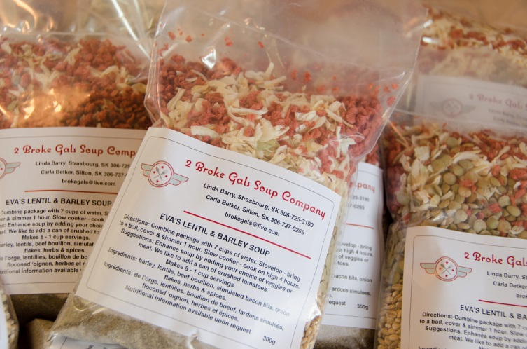 Eva’s Lentil and Barley – an exceptional soup full of heart-healthy goodness. It is extremely low in sodium and BIG on taste. We love it best with the addition of canned stewed tomatoes. With Saskatchewan grown ORGANIC Lentils and Barley this is one hardy soup.

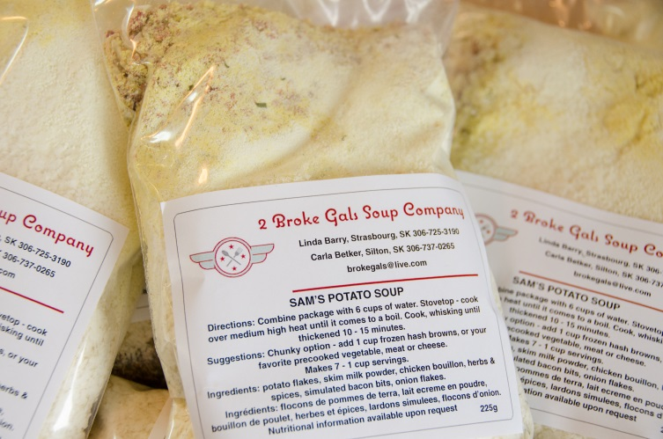 Sam’s Potato Soup – this extremely popular mix is so quick to prepare! In just 15 minutes you have a rich, thick and creamy soup. A great soup on its own, it is also easy to change up by adding one of your favorite foods like veggies, seafood or meat. The possibilities are endless! This is definitely a versatile addition to your pantry.
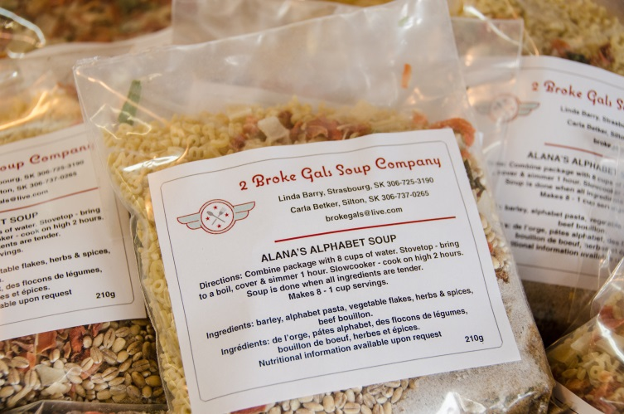 Alana’s Alphabet Soup – who doesn’t love alphabet pasta! This soup mix has it all. Fun alphabet pasta, ORGANIC Saskatchewan grown barley and great tasting nutritious veggies. So good! Need your protein? This one pairs very well with the addition of browned ground beef.
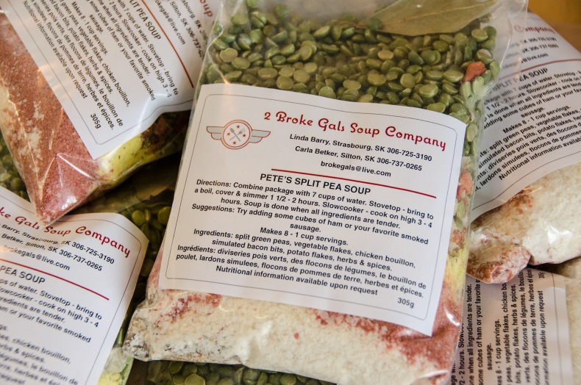 Pete’s Split Pea Soup – Featuring ORGANIC Saskatchewan grown green split peas along with a great blend of veggies, herbs and spices. The longer you cook it the smoother and more flavourful it becomes. The addition of smoked ham or sausage is a great compliment to this soup mix.

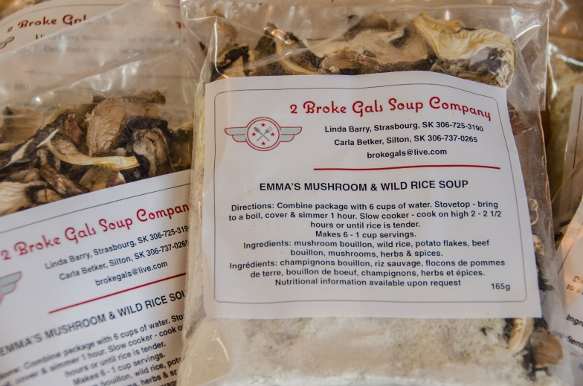 Emma’s Mushroom & Wild Rice Soup – a gourmet styled soup made with ORGANIC Saskatchewan grown wild rice and a custom blend of mushrooms containing four different varieties. Could it get any better?

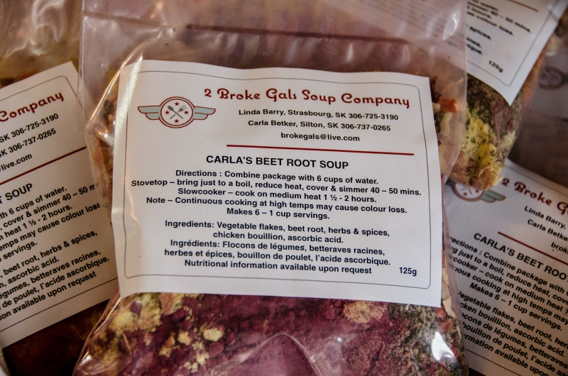 Carla’s Beet Root Soup – Now the flavors of the much loved summer favorite of borscht can be enjoyed all year round. Not only is this soup full of flavour, it is jam-packed with loads of health benefits. Beets really are a ‘souper’ food!

